

Innovation Ground Rounds
Innovation Ground Rounds - 8/21/2026 Transforming Healthcare through Digital Medicine: Right Care for the Right Patient at the Right Place

Innovation Grand Rounds is an interprofessional educational series designed to help MaineHealth care team members and community participants identify unmet healthcare needs, understand how innovation happens, and explore how to take the first steps toward improving care delivery. At its core, the series builds a culture of innovation mindset and capabilities—equipping participants to think creatively, collaborate effectively, and lead change with purpose. Innovation Grand Rounds features leading innovators in healthcare, showcasing their real-world innovation journeys—from identifying unmet needs to developing and implementing solutions. Faculty include clinicians, innovation leaders, and subject matter experts actively advancing innovation across MaineHealth. Through case-based presentations, real-world examples, and interactive discussions, participants gain practical understanding of key innovation concepts, including: Identifying and framing meaningful healthcare challenges Understanding user discovery and stakeholder engagement to strengthen ideation Recognizing value and feasibility in early-stage solutions Navigating pathways for advancing ideas, including technology disclosure and intellectual property considerations Exploring methods for testing and refining solutions, including when clinical research is required Rather than serving as a forum to fully develop projects, this series focuses on building awareness, strengthening foundational skills, and activating participants to take the next step. Importantly, the series connects participants to the MaineHealth Innovation lifecycle, helping them understand how ideas evolve—from problem identification and concept exploration to validation, development, and implementation—while highlighting clear entry points for care team members to begin and advance their innovation journey.
Please sign up for this session at this link: https://form.jotform.com/261973813112051

08/21/2026

Dana Center/Online

Goals or Objectives:
1 Identify problems and opportunities in the provision of healthcare
2 Understand the process of customer engagement to enhance ideation
3 Understand the process of technology disclosure and patenting
4 Develop methods for testing of innovations and solutions in healthcare
5 Understand when the step in development of an idea into an innovation will require clinical research

Accreditation:

 | In support of improving patient care, MaineHealth is jointly accredited by the Accreditation Council for Continuing Medical Education (ACCME), the Accreditation Council for Pharmacy Education (ACPE), and the American Nurses Credentialing Center (ANCC), to provide continuing education for the healthcare team. MaineHealth is also approved to accredit continuing education activities with the following credit types: Interprofessional Continuing Education (IPCE), Association of Social Work Boards (ASWB), American Academy of Physician Assistants (AAPA), American Psychological Association (APA), Registered Dietitians (RDs) and Dietetic Technicians, Registered (DTRs).

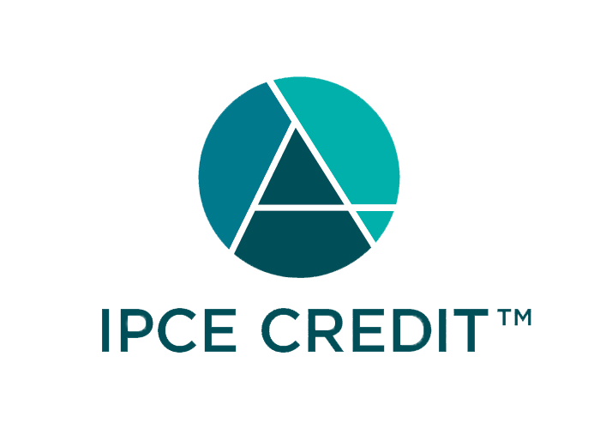





MaineHealth has been authorized by the American Academy of PAs (AAPA) to award AAPA Category 1 CME credit for activities planned in accordance with AAPA CME Criteria. This activity is designated for 1.00 AAPA Category 1 CME credits. PAs should only claim credit commensurate with the extent of their participation.



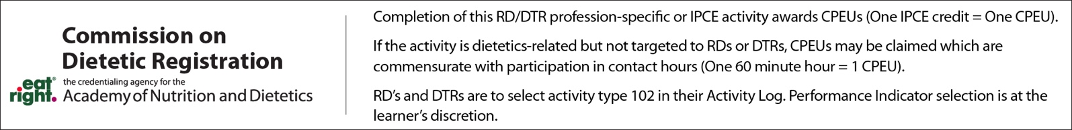

Credit Designation: Maine Medical Center designates this educational activity for a maximum of: 1.00 AMA PRA Category 1 Credit(s)™; 1.00 ANCC Contact Hour(s); 1.00 AAPA Category 1 CME Credit(s); 1.00 Non-Physician Credit(s);

Disclosure of Financial Relationships:
The following planners, moderators or speakers have the following financial relationship(s) with commercial interests to disclose:

Name of individual | Individual's role in activity | Nature of Relationship(s) / Name of Ineligible Company(s)
Jonathan Angus, PharmD | Faculty | Stocks or stock options, excluding diversified mutual funds-Abbvie|Stocks or stock options, excluding diversified mutual funds-Geron|Stocks or stock options, excluding diversified mutual funds-Agenus|Stocks or stock options, excluding diversified mutual funds-GSK|Stocks or stock options, excluding diversified mutual funds-Crispr Therapeutics|Stocks or stock options, excluding diversified mutual funds-Beam Therapeutics (Relationship has ended) - 07/21/2026
Amanda Bennett, MSN | Other Planning Committee Member | Nothing to disclose - 09/24/2025
Kristi Collins, PA-C | Co-Director | Nothing to disclose - 07/02/2026
Carla A Muniz, N/A | Activity Administrator | Nothing to disclose - 07/09/2026
Douglas B Sawyer, MD, PhD | Course Director | Nothing to disclose - 04/27/2026
Apurv Soni, MD, PhD | Faculty | Consulting Fee-UT Health San Antonio|Consulting Fee-Shields Health|Honoraria-Hallym University|Independent Contractor (included contracted research)-ARPA-H (Relationship has ended)|Advisor-FDA (Relationship has ended) - 07/21/2026
Ashleigh Taylor | Other Planning Committee Member | Nothing to disclose - 07/15/2026
Tucker Witter, Other | Other Planning Committee Member | Nothing to disclose - 12/30/2025

