How to Register for an event in CloudCME:

Step One: Navigate to mainehealth.cloud-cme.com and select “sign in” in the navigation bar.
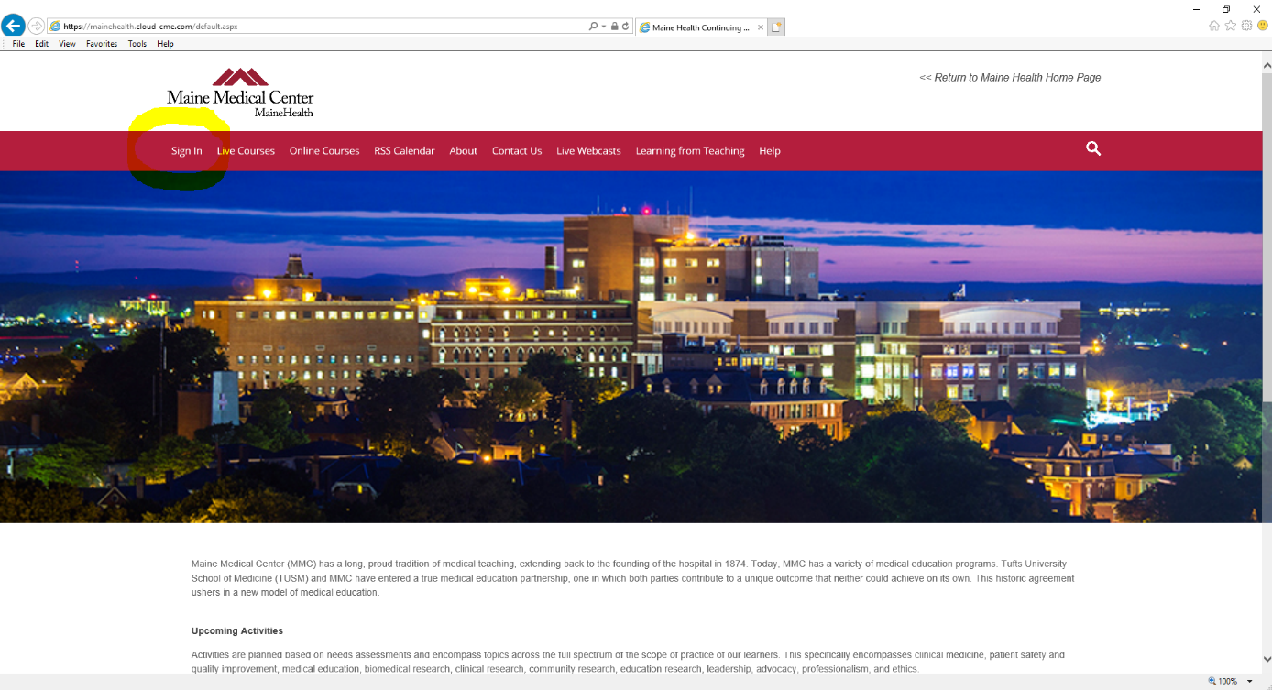

Step Two:
If you have an email ending in @mmc.org : Select “Sign in with your MaineHealth ID” NOTE: If you’re accessing the site on IE, the sign on should happen automatically. If on chrome it will bring you to an additional page, where you must login with your name as follows: mmcf\username or username@mmcf.mehealth.org .

If you have any other email address : Select “Sign in with your Email and Password” using the email you have on file. Your default password is your last name with the first letter capitalized.

Step Three:
Once signed in, select “Live Courses”. From there, you will see a button to Register. Complete the registration information and included survey. You will receive an email confirming that your registration is then complete.
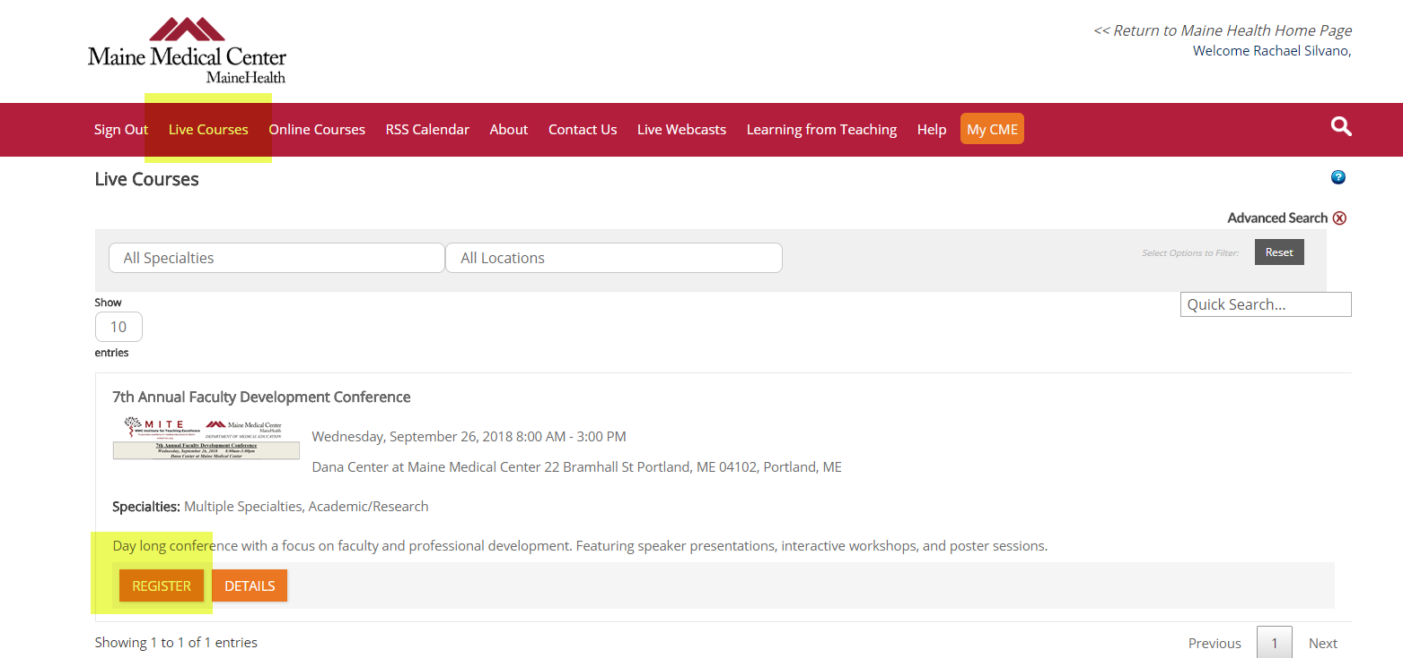

Questions? Please contact: cloudcmehelp@mmc.org with inquires about CloudCME.

