

Pulmonary Grand Rounds

A recurring conference given by invited outside experts in the Pulmonary field presenting their research and/or up to date clinical data and practice.
For more information on attending the grand rounds, email Kalie Smith at kalie.smith@mainehealth.org

08/25/2026

22 Bramhall St, Portland ME 04102

Goals or Objectives:
1 Apply current evidence and clinical guidelines to the diagnosis and management of complex pulmonary conditions.
2 Evaluate emerging diagnostic approaches, therapeutic strategies, and advances in pulmonary medicine to improve patient care.

3 Integrate updated clinical knowledge into practice through evidence-based decision-making and multidisciplinary collaboration.

Accreditation:

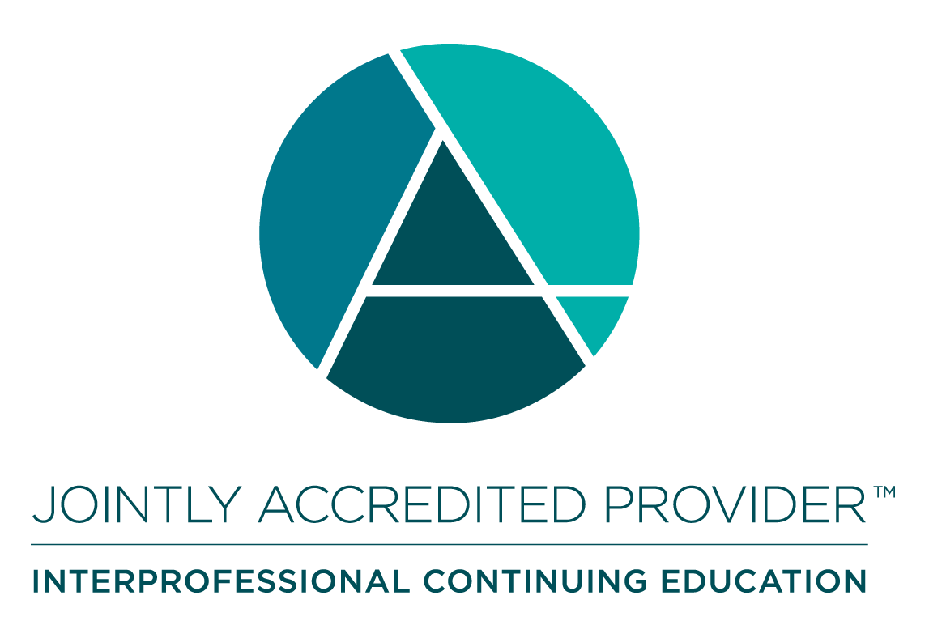 | In support of improving patient care, MaineHealth is jointly accredited by the Accreditation Council for Continuing Medical Education (ACCME), the Accreditation Council for Pharmacy Education (ACPE), and the American Nurses Credentialing Center (ANCC), to provide continuing education for the healthcare team. MaineHealth is also approved to accredit continuing education activities with the following credit types: Interprofessional Continuing Education (IPCE), Association of Social Work Boards (ASWB), American Academy of Physician Assistants (AAPA), American Psychological Association (APA), Registered Dietitians (RDs) and Dietetic Technicians, Registered (DTRs).

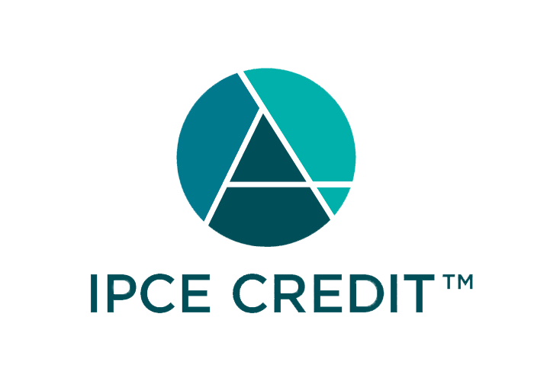



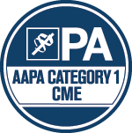



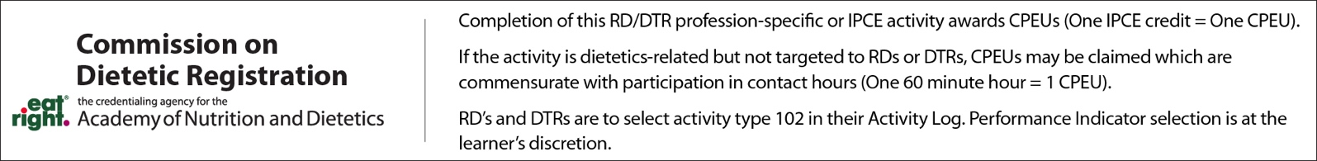

Credit Designation: Maine Medical Center designates this educational activity for a maximum of: 2.00 AMA PRA Category 1 Credit(s)™; 2.00 Non-Physician Credit(s);

Disclosure of Financial Relationships:
The following planners, moderators or speakers have the following financial relationship(s) with commercial interests to disclose:

Name of individual | Individual's role in activity | Nature of Relationship(s) / Name of Ineligible Company(s)
Meagan Moore, MD, PhD | Course Director | Nothing to disclose - 07/28/2026
Kalie Smith | Activity Administrator | Nothing to disclose - 06/24/2026

