

MH Neurology Scarborough Grand Rounds

1 hour lecture regarding various contemporary topics in the field of Neurology. This may include updates to disease pathophysiology and genetics, updates to treatment paradigms. This may include various resources in the community. We also offer faculty development lectures to improve our educational methods. Finally, we will review clinical cases, whether imaging, EEG, or history, to improve patient care/outcome. Contact Neurology Department for schedule.

09/03/2026

92 Campus Drive

Goals or Objectives:
1 Identify new or updated topics, techniques, and approaches to incorporate into current patient care.
2 Identify and describe Neurology sub-specialties.
3 Recognize and describe standard practices of other fields that impact Neurological care

Accreditation:

 | In support of improving patient care, MaineHealth is jointly accredited by the Accreditation Council for Continuing Medical Education (ACCME), the Accreditation Council for Pharmacy Education (ACPE), and the American Nurses Credentialing Center (ANCC), to provide continuing education for the healthcare team. MaineHealth is also approved to accredit continuing education activities with the following credit types: Interprofessional Continuing Education (IPCE), Association of Social Work Boards (ASWB), American Academy of Physician Assistants (AAPA), American Psychological Association (APA), Registered Dietitians (RDs) and Dietetic Technicians, Registered (DTRs).

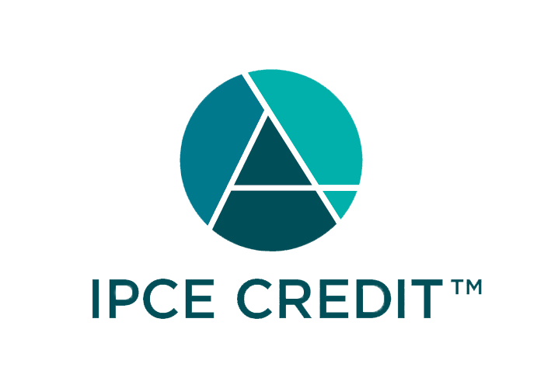



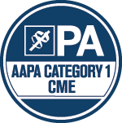



Continuing Education (CE) credits for psychologists are provided through the co-sponsorship of the American Psychological Association (APA) Office of Continuing Education in Psychology (CEP). The APA CEP Office maintains responsibility for the content of the programs.

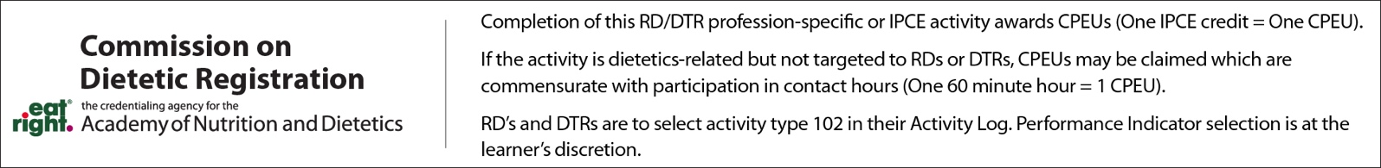

Credit Designation: Maine Medical Center designates this educational activity for a maximum of: 1.00 AMA PRA Category 1 Credit(s)™; 1.00 ANCC Contact Hour(s); 1.00 APA CE Credit(s);

Disclosure of Financial Relationships:
The following planners, moderators or speakers have the following financial relationship(s) with commercial interests to disclose:

Name of individual | Individual's role in activity | Nature of Relationship(s) / Name of Ineligible Company(s)
Lisa Bulthuis | Other Planning Committee Member | Nothing to disclose - 08/04/2026
Christine Lu-Emerson, MD | Course Director | Honoraria-NCI Brain Malignancy Steering Committee - 07/27/2026
Diana Page | Nurse Planner | Nothing to disclose - 07/27/2026
Gretchen Schoenfield, PhD | Other Planning Committee Member | Nothing to disclose - 07/23/2026
Lisa Torrey-Roderick | Activity Administrator | Nothing to disclose - 07/23/2026

