

Pharmacy Grand Rounds

Pharmacy Grand Rounds is a monthly educational series for pharmacists, pharmacy technicians, and other interested healthcare professionals. The purpose is to present current guidelines for medication management of a variety of disease states, provide updates on new and innovative developments in pharmacotherapy research and technology, and address therapeutic dilemmas and controversies in medication management that health professionals face.

11/03/2026

Dana Center, MH MMC Portland

Goals or Objectives:
1 Describe the epidemiology, pathophysiology, and pharmacotherapy for disease states commonly encountered in practice.
2 Summarize evidence-based medical literature and how to incorporate this information into clinical decision making and recommendations to the healthcare team.
3 Discuss developing research and technology in the treatment of common disease states, including controversial pharmacotherapy topics.

Accreditation:

 | In support of improving patient care, MaineHealth is jointly accredited by the Accreditation Council for Continuing Medical Education (ACCME), the Accreditation Council for Pharmacy Education (ACPE), and the American Nurses Credentialing Center (ANCC), to provide continuing education for the healthcare team. MaineHealth is also approved to accredit continuing education activities with the following credit types: Interprofessional Continuing Education (IPCE), Association of Social Work Boards (ASWB), American Academy of Physician Assistants (AAPA), American Psychological Association (APA), Registered Dietitians (RDs) and Dietetic Technicians, Registered (DTRs).

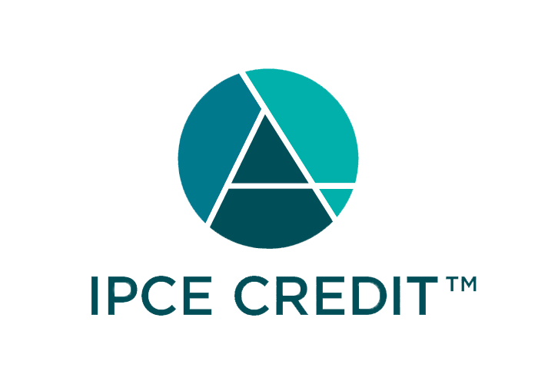

This activity was planned by and for the healthcare team, and learners will receive 1.00 Interprofessional Continuing Education (IPCE) credits for learning and change.



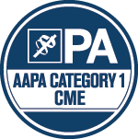



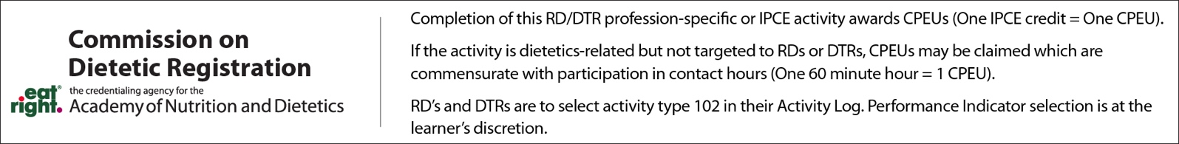

Credit Designation: Maine Medical Center designates this educational activity for a maximum of: 1.00 Interprofessional Continuing Education Credit(s); 1.00 AMA PRA Category 1 Credit(s)™; 1.00 ACPE Credit(s); 1.00 Non-Physician Credit(s);

Disclosure of Financial Relationships:
The following planners, moderators or speakers have the following financial relationship(s) with commercial interests to disclose:

Name of individual | Individual's role in activity | Nature of Relationship(s) / Name of Ineligible Company(s)
Jillian M Barnes, PharmD | Activity Administrator, Co-Director | Nothing to disclose - 08/19/2026
Jonathan Bourque, PharmD | Course Director | Nothing to disclose - 10/02/2026
Lorraine L McElwain | Other Planning Committee Member | Nothing to disclose - 09/30/2026

